**100 Books To Read In Key Stage 1**

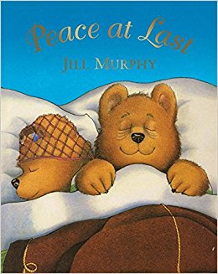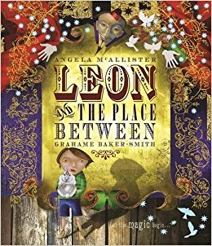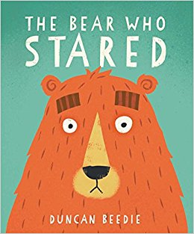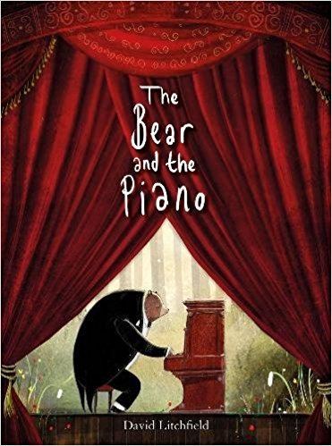

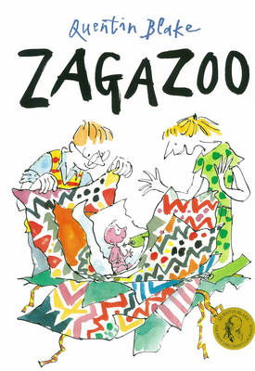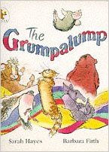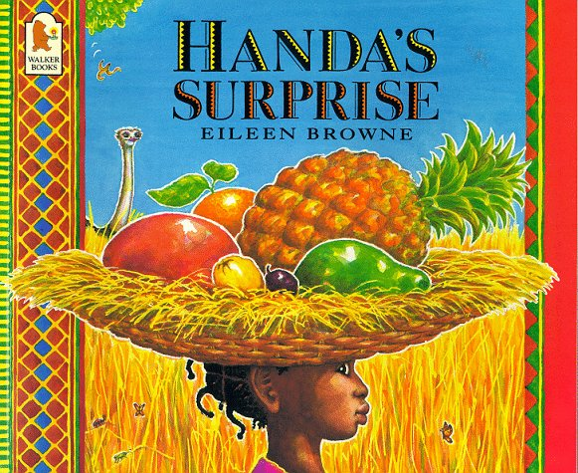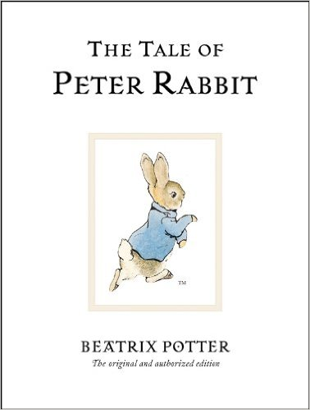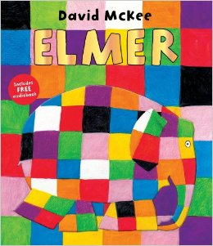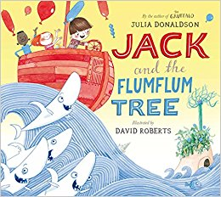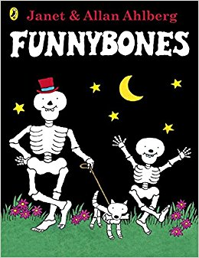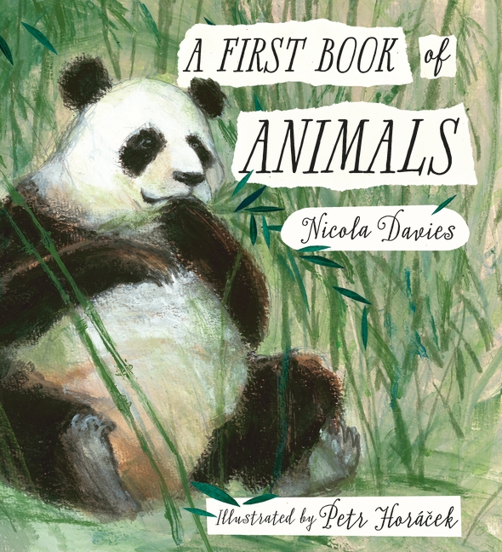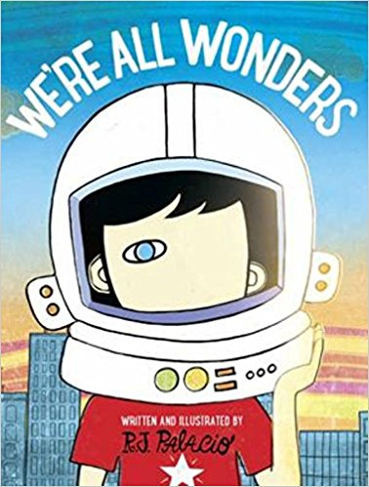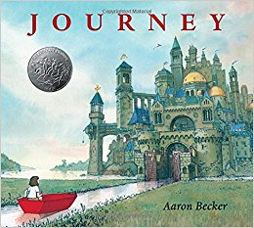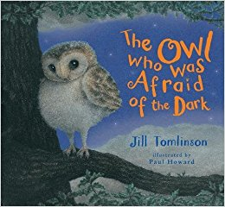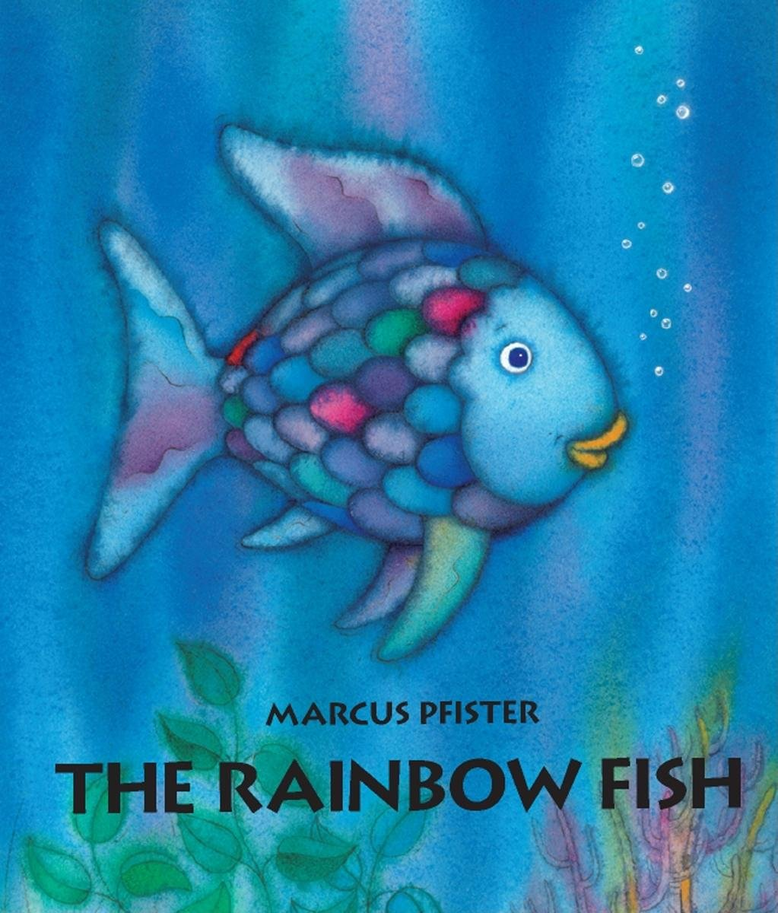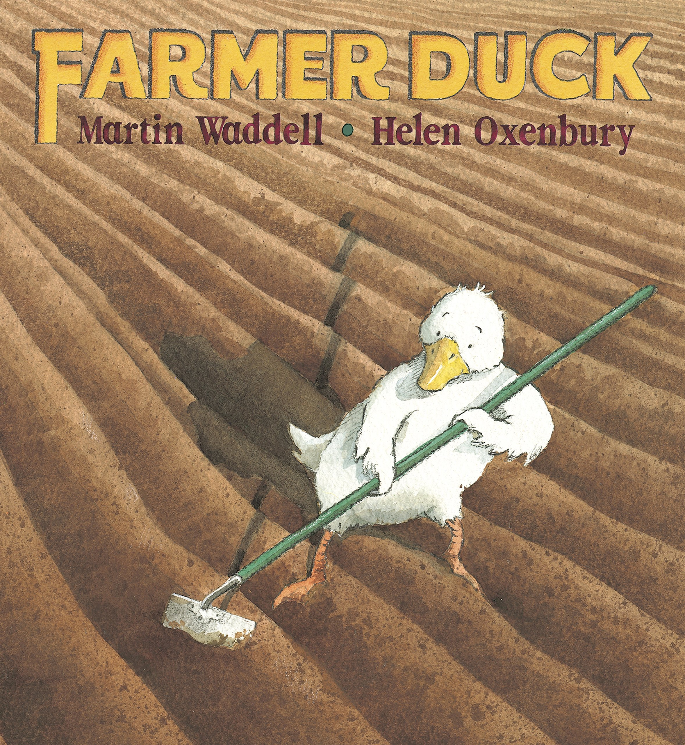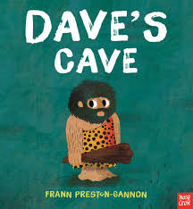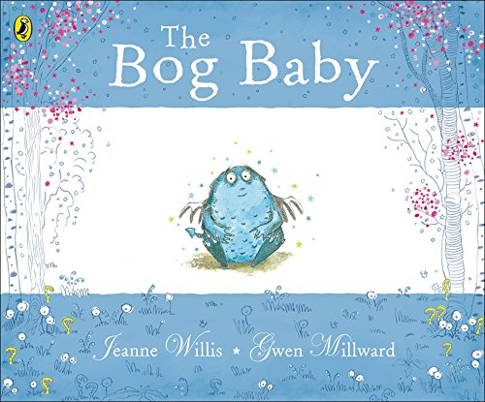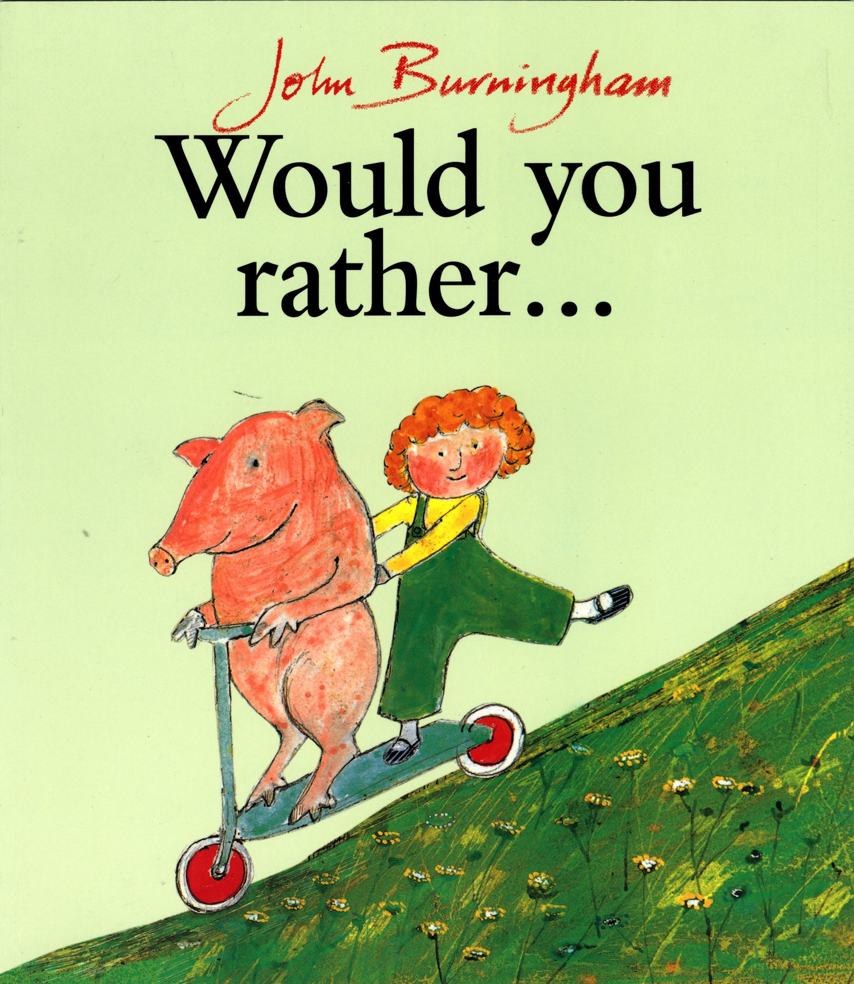

The Rainbow Fish

Marcus Pfister

The Bog Baby

Jenne Willis and Glen Millward

We’re All Wonders

RJ Palacio

Farmer Duck

Martin Waddell and Helen Oxbury

Peace At Last

Jill Murphy

Zagazoo

Quentin Blake

The Grumpalump

Sarah Hayes

The Great Dog Bottom Swap

Peter Bently and Mel Matsuoka

Handa’s Surprise

Eileen Browne

The Tale Of Peter Rabbit

Beatrix Potter

Elmer

Dacid McKee

Jack and the Flumflum Tree

Julia Donaldson

The Bear and The Piano

David Litchfield

Funnybones

Janet and Allan Ahlberg

A First Book Of Animals

Nicola Davies

Journey

Aaron Becker

The Owl Who Was Afraid Of The Dark

Jill Tomlinson

Dave’s Cave

Frann Preston-Gannon

Leon and the Place Between

Angela McAllister and Grahame Baker-Smith

The Bear Who Stared

Duncan Beedie

Would You Rather…

John Burningham