**100 Books To Read In Year 5 and 6**

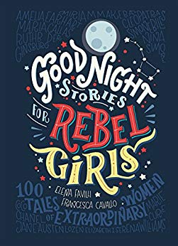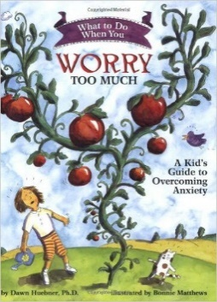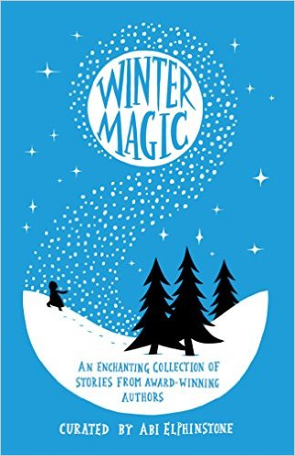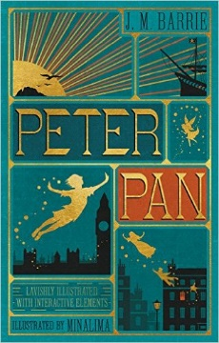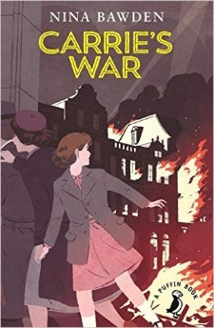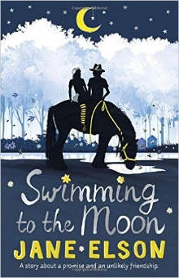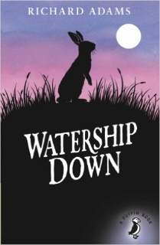

Skullduggery Pleasant

Derek Landy

The Wonderful Wizard of Oz

L Frank Baum

The Miraculous Journey of Edward Tulane

Kate DiCamillo

Carrie’s War

Nina Bawden

The Goldfish Boy

Lisa Thompson

101 Poems for Children

Carol Ann Duffy

Liz Pichon

Howl’s Moving Castle

Diana Wynne Jones

There May Be A Castle

Piers Toarday

The Invention of Huge Cabret

Brian Selznick

What to Do When You Worry Too Much

Dawn Huebner

Winter Magic  
  
Stories by Various Authours

Peter Pan

JM Barrie

Swimming to the Moon

Jane Eslson

Watership Down

Richard Adams

Goodnight Stories For Rebel Girls

Elena Favilli and Francesca Cavallo

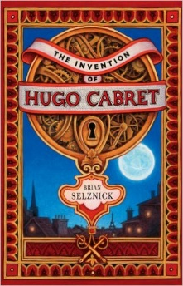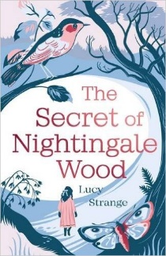

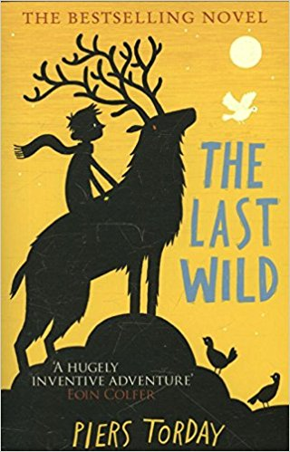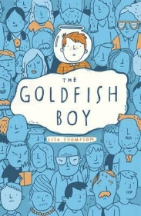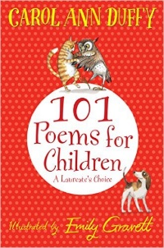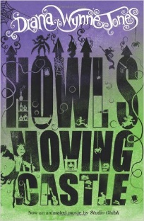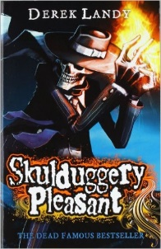

The Secret of Nightingale Wood

Lucy Strange

