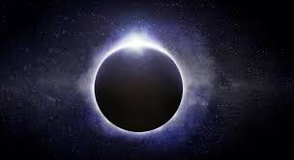
RARE SOLAR ECLIPSE

On Friday 20 March 2015 we got to see this wonderful event. A solar eclipse is where the moon passes in front of the sun.
If you want to know more, here are some facts:
- We have not seen a Solar Eclipse since 1999.
- When this happens, in some places the sky is dark and dim.
3. This very rare event can last for up to two hours.
4. Looking directly at the sun can damage your eyes, or it can even cause blindness. You should use a special sun-viewer or glasses.

